

Putnam Church Preschool
2019-2020

PM Pre-K

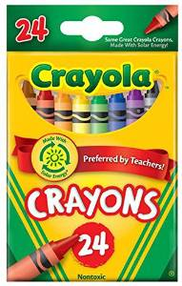
Student Supply List

1 pkg Crayola (24 count) crayons

1 pkg Crayola (10 count) Broad Line markers (any colors)

1 large Elmer’s glue stick

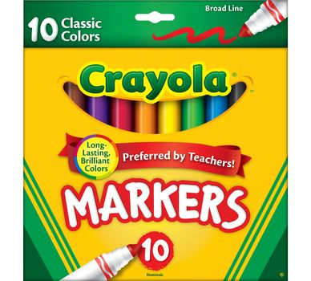
1 pkg Clorox cleaning wipes

1 box Dixie 5 oz. cups

2 pkgs small (6 inch) paper plates

1 roll paper towels

1 pkg large size (12x18) construction paper

1 pocket folder
(to be used as a daily folder)

1 backpack
(large enough to easily insert and remove daily folder)

Please make sure that your child’s name is written clearly on the
daily folder and on the outside of the backpack.
All other items will be shared by the group, so names are not necessary.

